|  |
| --- |
| **Project Team Charter** **ME476C: Capstone I** **Signature Cover Page** |

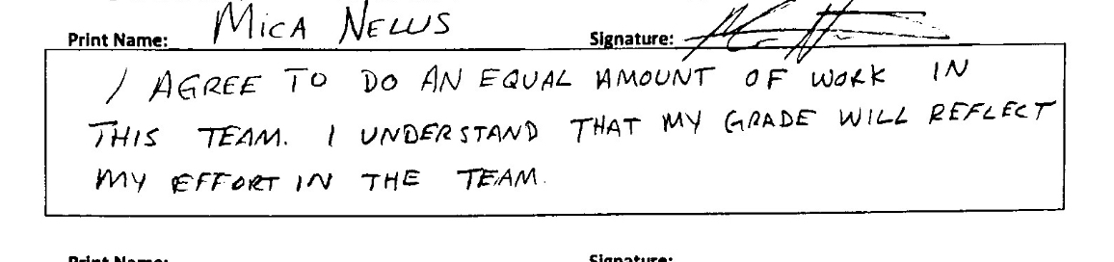

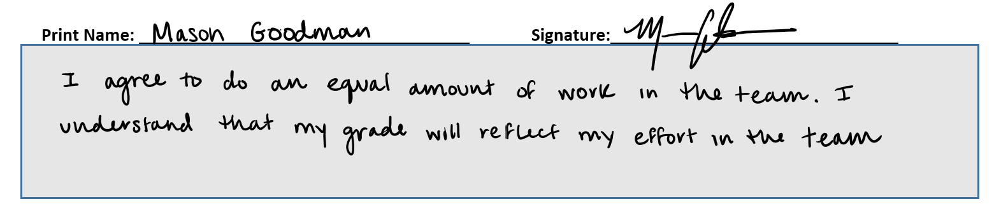

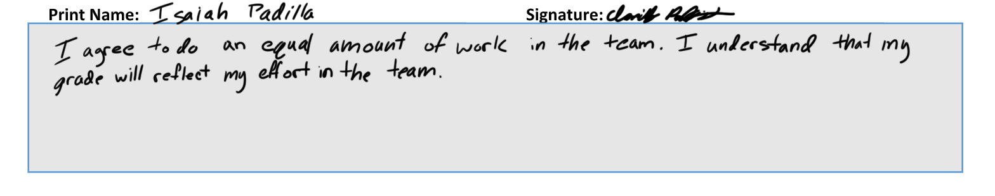

Print Name: Signature:



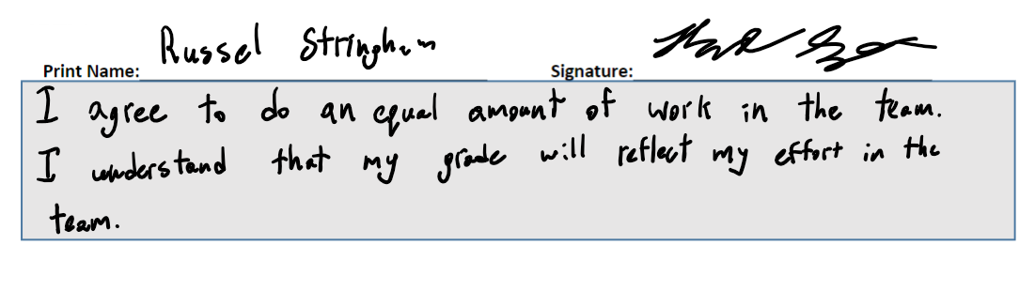

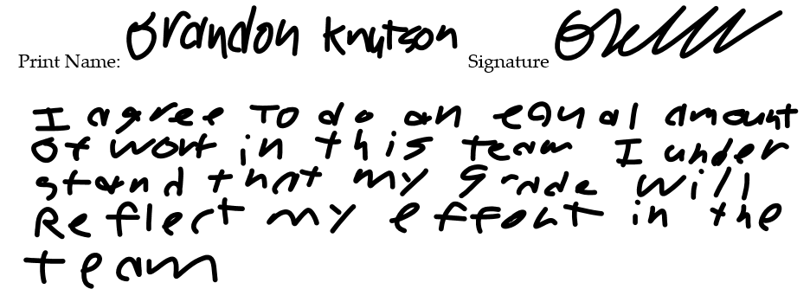

**To: Dr. David Willy; Husain Sodawalla**

**From: Northrup Grumman Drill Arm Team**

**Date: 9-8-23**

**Re: Team Charter**

**Introduction**

The members of the engineering team undertaking the Robot Drill Arm Capstone Project are committed to delivering an innovative and reliable solution for Northrop Grumman. This team charter serves as a foundational document to guide our mission, objectives, and collaborative efforts throughout the project.

Our team's purpose is to design, develop, and deliver the Robot Drill Arm system that will not only meet but also exceed Northrop Grumman’s expectations, all before the next Northrup Grumman Design Day. We aim to provide a versatile and adaptable robotic arm capable of performing a wide range of drilling and machining tasks within desired tolerances.

Our team is aware of the expectations and is dedicated to achieving them with great passion. The team is also willing to achieve extra and optional goals as such opportunities arise. Our commitment to excellence will be the driving force behind our project's success, ensuring that the robot drill arm becomes an invaluable resource to Northrup Grumman.

**Team Purpose**

The team was formed to fulfill Northrup Grumman’s proposal request. The proposal is for an articulated robot drill arm design capable of locating any area on a cylindrical object and drilling the appropriately sized hole autonomously. It is also desirable that the drill arm has multiple bits on hand to be selected from as a toolset for varying hole requirements. The purpose of the project itself also serves to minimize the communication, costs, and time required to accomplish the drilling task as compared to current resources. As such, the efficiency of the drilling task will be greatly improved.

The team’s stakeholders include Northrup Grumman, Dr. David Willy, the team, and any investors of the team itself. Northrup Grumman expects that the team will be able to attain both of their deliverable goals for a location system and the actual articulated robot drill arm itself by the time the deadline for Northrup Grumman’s Design Day arrives. The company also expects that the team will put its best efforts into researching, designing, manufacturing, and building a quality instrument that will serve Northrup Grumman’s purposes well. Finally, the team expects that it will put its best foot forward and represent not only itself, but also NAU’s engineering department, the best it can.

**Team Goals**

The team discussed our goals for the project, process, and output quality of our capstone. For the project, Northrup Grumman wants the team to create a successful Robot Drill Arm system that meets all the customers' requirements. Meeting the needs of the customer is the team’s most important goal for the project. The project's process goal was to ensure the team ran smoothly and completed all tasks quickly. To create a successful design, it is important to not fall behind, so the workload does not continue to grow. All team members will have to hold each other accountable, so each person completes their tasks on time. The quality of the design is particularly important for the team to ensure the customer is satisfied with the product.

It is the entire team’s goal to achieve a final class grade of at least 90% for both semesters of the capstone class. For each assignment, the team will apply maximum effort, combined with constructive feedback and guidance from Dr. Willy, to achieve a grade of 90% or better on all team assignments. This goal will be reached by maintaining consistent contact with team members, reviewing fellow teammates' work to ensure accuracy and quality, and completing work well before the deadline. By holding each other accountable, the team will successfully complete assignments to reach the final grade goal.

The final team goal is to attend Northrup Grumman Design Day and deliver a presentation to the clients that can not only compete with the other schools involved in the project but exceed their expectations. The entire team understands that the goal is to work together to design and build a product unique to the clients while outperforming the products provided by the other schools.

**Team Personalities**

After taking the 16 personalities online MBTI test, Brandon Knutson found that he was typed as an assertive commander with his most prominent traits being intuition and judgment. The other three traits were evenly split between the two options. Because of Brandon’s Imaginative trait, he should be prescribed to tasks that require thinking freely, innovating off of previous design ideas, and producing new ones. For Brandon's second strongest trait of structure, he should oversee his part of the projects scheduling to ensure his structure and order requirements are met. Brandon will serve as the team’s Manufacturing Engineer as a result.

From his MBTI test, Isaiah Padilla was categorized as an ENFJ type, a leader with a good sense of how to lead people in a fair and considerate manner. The chief traits which appeared for him are reliability, altruism, and passion for what he does. Because of these traits, he would benefit from taking on communication-related tasks, such as website updates or checking in with the team. He would also do well to ensure that the team’s submissions consistently remain of high quality, of a similar structure and format, and that they are on time, all through a review and editing process. Isaiah will be in charge of editing and formatting the team’s papers as well as being the team’s Project Manager. This will entail that he will check in with the sub teams to make sure everyone is on schedule and that he can update the website accordingly, as well as report any important updates to the team or the stakeholders as necessary.

To decide his role for the team, Russel Stringham took the 16 personalities online MBTI test, with the result being ESTJ-A. The results showed him as an executive with great organization and leadership traits. With these traits, he will keep the team organized and on track to complete a successful project. This will come in handy since Russel will be undertaking scheduling tasks and making sure his other sub team members are completing their tasks. From previous experience Russel will focus heavily on the CAD design aspects of the project to oversee the development of the CAD models and drawings. As the team’s CAD Engineer, he will manage the CAD files and ensure it all comes together to match the physical design.

In deciding her role in the team, Mica Nellis took the 16 personalities online MBTI test, with the end results being INFJ-T. Given these results, Mica will be able to keep all meetings neutral as well as organized to make sure that all members are being heard and that any ground rules are being followed by the team. Mica will take on the Logistics Manager role as her main objective, reaching out to the client, making sure that meetings are set, and that all members involved are working together smoothly. Additionally, she will document meeting minutes and all resources used throughout the project. Additionally, Mica will assist Russel with the CAD portions of the project in any way possible since there will be a high amount of CAD modeling throughout this project.

It was determined through taking the personality test that Daniel has an ESTP-A personality type, which categorizes him as the “entrepreneur” of the group. His extroverted social skills will allow him to act as the liaison between the team and the clients, alongside Mica, as constant communication is necessary to have a successful team. Daniel is also 80% “Thinker” over “Feeler”, giving him the ability to provide rational courses of action that may be more achievable than others. If the team selects a final design that is not possible to construct under the given timeline and budget, this team member may offer alternative solutions. The test described Daniel’s number one strategy as people mastery. By being able to take notice of team members’ strengths, he will be able to delegate tasks to the appropriate team member to ensure maximum effort and output quality. Based on his personality description, Daniel will take on the team role of Financial Manager, as that role must be filled by someone who is rational and practical. Within the role, he will take the role of managing the budget, overseeing purchases, and maintaining the bill of materials as a working document. Daniel will also be a part of the four-person group that designs the arm subsystem for the drill.

To determine the best team role for Mason Goodman, he took an MBTI personality test, with the results showing that he has an ESTJ-A personality type. This categorizes Mason as an “executive” personality type that is an excellent organizer who enjoys creating order. Mason will be able to help the team create and maintain a schedule. Mason will also act as the team’s Test Engineer who will oversee experimental design and testing, plan testing procedures, and acquire necessary testing equipment. As the second “executive” personality type, various accessory roles and responsibilities will be delegated to Mason, which will be determined as the project continues. A list of team member roles and descriptions can be found in Table 1: Team Roles and Descriptions.

Table 1: Team Roles and Descriptions

|  |  |  |
| --- | --- | --- |
| Team Member Name | Role Title | Role Description |
| Isaiah Padilla | Project Manager | Manages tasks, develops overall schedule, runs meetings, reviews individual contributions, provides safe and welcoming team environment, does NOT make all decisions (facilitates discussion of the team to arrive at team decisions) |
| Mica Nellis | Logistics Manager | Manages internal and external communication (point of contact for client), documents meeting minutes, manages facility and resource usage |
| Daniel Cooke | Financial Manager | Oversees all purchases, main contact with Front office for budget management, monitors and records all purchases for budget tracking, updates Bill of Materials |
| Mason Goodman | Test Engineer | Oversees experimental design and testing, plans testing procedures, acquires necessary equipment for testing, runs all tests for team |
| Brandon Knutson | Manufacturing Engineer | Coordinates fabrication of design (does NOT do all manufacturing themselves), reviews design at all steps, ensures design can be manufactured, finds outsourcing opportunities manufacturing cannot be done in-house, develops schedule of manufacturing |
| Russel Stringham | CAD Engineer | Coordinates and oversees CAD development throughout project, creates protocol for revision management, manages CAD files, ensures CAD model matches physical design, does NOT do entire CAD package themselves |

**Ground Rules**

The engineering team wants to fully succeed throughout this semester and work together in a manner that allows for success. The team plans to meet at a minimum once a week unless various deliverables require otherwise. By meeting at least once a week, this will allow the team to communicate face to face to ensure that all ideas and points are coming together effectively. For these meetings to happen in an organized fashion the team will create a Gantt Chart to ensure that all goals and deliverables are being met, that all team members’ schedules can align such that these meetings will be possible, and that the meetings will not be missed.

The team decided that it will hear and discuss all ideas in each member's mind and allow for constructive feedback on why or why not each idea is going to work for the capstone project. Based on these conversations, if there seems to be no clear idea that all members will agree on a majority vote will be taken. Due to the six members amongst this team, if the majority vote is in support of an idea, concept, or purchase in this project, then the decision will be made. Disagreements will happen within the project, but the team has agreed that the end goal is more important for the overall success as a team.

All members of the Northrop Grumman team have agreed to maintain the utmost respect for each other as well as have a significant level of understanding of the project and their respective roles throughout the entire semester. Upon agreement, it is expected to check in on one another when assignment due dates are approaching. A Microsoft Teams channel and group chat will be used to ensure that communication is easily accessible for every member. All members of the team should be extremely committed to the project and have come to the decision that everything accomplished has been done thus far in each member’s degree work has led to this moment. The team expects nothing but the best from each member going forward and looks forward to participating in this engineering challenge.

**Potential Barriers and Coping Strategies**

Across an eight-month project, setbacks and barriers to productive work are common within a team setting. To identify potential barriers the team discussed previous issues and experiences where overall productivity was affected. Three destructive dynamics previously experienced by team members in an academic setting were:

1. Difficult team members unreceptive to innovative ideas and/or unwilling to compromise.
2. Time management issues leading to error-prone documents and/or missed deadlines.
3. Imbalanced workload leading to peer to peer and/or team tension.

The team’s prior negative experiences can be attributed to teamwork barriers that progressed into a poor dynamic. Common daily obstacles include:

1. Poor Communication – Unclear expectations and different goals lead to failed objectives.
2. Poor Time Management – Unrealistic workloads and overlooked tasks create continuity issues.
3. Poor Planning – Failing to plan is planning to fail.
4. Poor Team Environment – Differences of opinions leading to lack of respect.

To help create an environment for effective teamwork and prevent materialization of team issues, it is important to be diligent about planning, expectations, and goals early in the project. Setting guidelines and procedures that hold authority throughout the project helps avoid conflict. As milestones are met, the team can evaluate interim performance and subsequently make process adjustments in accordance with charter agreements.

However, events do not always go as planned, and issues do materialize. When this occurs, it is important to be flexible through unplanned problems. If repeated setbacks and problems start to lead to a destructive team dynamic, any team member may request a meeting to discuss changes to project roles and/or charter addendums. The team’s ground rules include a process to address larger scale disagreements with a team vote. If changes are not seen, peer evaluations provide a platform to express team issues quantitatively affecting individual performance. If problems start to affect overall team performance, team reconfiguration will be discussed with the appropriate stakeholders.

**Conclusion**

In conclusion, our engineering team is dedicated in its commitment to delivering an innovative and reliable Robot Drill Arm system to Northrop Grumman. This team charter stands as a testament to the team’s collective dedication to guiding the mission, objectives, and collaborative efforts through this pivotal project.

The team’s primary purpose is clear: to design, develop, and deliver a robot drill arm system that not only meets but also exceeds Northrop Grumman’s expectations. The team is resolute in its pursuit of creating a versatile and adaptable robotic arm capable of performing a wide array of drilling and machining tasks with precision and efficiency, all while maintaining the highest standards of quality and safety that it can.